- Create VPC.
- Create Internet gateway.
- Create Custom Route Table.
- create Subnet.
- Associate subnet with Route Table.
- Create Security Group to allow port 22.80,443.
- Create a network interface with an ip in the subnet that was created in step 4.
- Assign an elastic IP to the network interface created in step 7.
- Create Ubuntu server and install/enable apache2.

Prerequisites
Required Tools

* AWS Account

* IAM User with:
AmazonEC2FullAccess
AmazonVPCFullAccess

* Terraform installed

*AWS CLI installed and configured

aws configure
terraform -version

Main.tf

# AWS provider.

provider "aws" {
region = var.aws_region
}

# Task 1 : VPC creation.

resource "aws_vpc" "custom_vpc" {
cidr_block = "10.0.0.0/16"
enable_dns_support = true
enable_dns_hostnames = true

tags = {
Name = "terraform-vpc"
}
}

# Task 2 : Internet Gateway creation.

resource "aws_internet_gateway" "igw" {
vpc_id = aws_vpc.custom_vpc.id

tags = {
Name = "terraform-igw"
}
}

# Task 3 : Custom Route Table creation.

resource "aws_route_table" "custom_rt" {
vpc_id = aws_vpc.custom_vpc.id

route {
cidr_block = "0.0.0.0/0"
gateway_id = aws_internet_gateway.igw.id
}

tags = {
Name = "terraform-route-table"
}
}

# Task 4 : Subnet creation.

resource "aws_subnet" "public_subnet" {
vpc_id = aws_vpc.custom_vpc.id
cidr_block = "10.0.1.0/24"
availability_zone = "us-east-1b"
map_public_ip_on_launch = true

tags = {
Name = "public-subnet"
}
}

# Task 5 : Associate subnet with custom Route Table creation.

resource "aws_route_table_association" "rt_association" {
subnet_id = aws_subnet.public_subnet.id
route_table_id = aws_route_table.custom_rt.id
}

# Task 6 : Security Group creation to allow port 22.80,443.

resource "aws_security_group" "web_sg" {
name = "terraform-sg"
description = "Allow SSH, HTTP, HTTPS"
vpc_id = aws_vpc.custom_vpc.id

ingress {
from_port = 22
to_port = 22
protocol = "tcp"
cidr_blocks = ["0.0.0.0/0"]
}

ingress {
from_port = 80
to_port = 80
protocol = "tcp"
cidr_blocks = ["0.0.0.0/0"]
}

ingress {
from_port = 443
to_port = 443
protocol = "tcp"
cidr_blocks = ["0.0.0.0/0"]
}

egress {
from_port = 0
to_port = 0
protocol = "-1"
cidr_blocks = ["0.0.0.0/0"]
}

tags = {
Name = "terraform-sg"
}
}

# Task 7 : Network Interface with an ip in subnet.

resource "aws_network_interface" "web_eni" {
subnet_id = aws_subnet.public_subnet.id
private_ips = ["10.0.1.10"]
security_groups = [aws_security_group.web_sg.id]

tags = {
Name = "terraform-eni"
}
}

# Task 8 : Assingn Elastic IP to Network Interface creation.

resource "aws_eip" "web_eip" {
domain = "vpc"
network_interface = aws_network_interface.web_eni.id
associate_with_private_ip = "10.0.1.10"

tags = {
Name = "terraform-eip"
}
}

# Task 9 : EC2 Instance (ubuntu) creation with user data to install Apache web server.

resource "aws_instance" "ubuntu_server" {
ami = var.ami_id
instance_type = "t3.micro"
key_name = var.key_name

user_data = <<-EOF
#!/bin/bash
apt update -y
apt install apache2 -y
systemctl start apache2
systemctl enable apache2
EOF

tags = {
Name = "ubuntu-apache"
}
}

Variables.tf

variable "aws_region" {
description = "AWS region"
default = "us-east-1"
}

variable "ami_id" {
description = "AMI ID"
default = "ami-0b6c6ebed2801a5cb" # Ubuntu server (us-east-1)
}

variable "key_name" {
description = "EC2 key pair name"
default = "logical"
}

Outputs.tf

output "vpc_id" {
description = "ID of the custom VPC"
value = aws_vpc.custom_vpc.id
}

output "vpc_cidr_block" {
description = "CIDR block of the custom VPC"
value = aws_vpc.custom_vpc.cidr_block
}

output "internet_gateway_id" {
description = "ID of the Internet Gateway"
value = aws_internet_gateway.igw.id
}

output "route_table_id" {
description = "ID of the custom route table"
value = aws_route_table.custom_rt.id
}

output "subnet_id" {
description = "ID of the public subnet"
value = aws_subnet.public_subnet.id
}

output "subnet_cidr_block" {
description = "CIDR block of the public subnet"
value = aws_subnet.public_subnet.cidr_block
}

output "subnet_availability_zone" {
description = "Availability Zone of the public subnet"
value = aws_subnet.public_subnet.availability_zone
}

output "security_group_id" {
description = "ID of the web security group"
value = aws_security_group.web_sg.id
}

output "security_group_name" {
description = "Name of the web security group"
value = aws_security_group.web_sg.name
}

output "security_group_vpc_id" {
description = "VPC ID associated with the security group"
value = aws_security_group.web_sg.vpc_id
}

output "network_interface_id" {
description = "ID of the network interface"
value = aws_network_interface.web_eni.id
}

output "network_interface_private_ip" {
description = "Private IP address of the network interface"
value = aws_network_interface.web_eni.private_ip
}

output "elastic_ip_public_ip" {
description = "Public IP address of the Elastic IP"
value = aws_eip.web_eip.public_ip
}

output "instance_id" {
description = "ID of the EC2 instance"
value = aws_instance.ubuntu_server.id
}

output "instance_private_ip" {
description = "Private IP address of the EC2 instance"
value = aws_instance.ubuntu_server.private_ip
}

output "instance_public_ip" {
description = "Public IP address of the EC2 instance"
value = aws_instance.ubuntu_server.public_ip
}

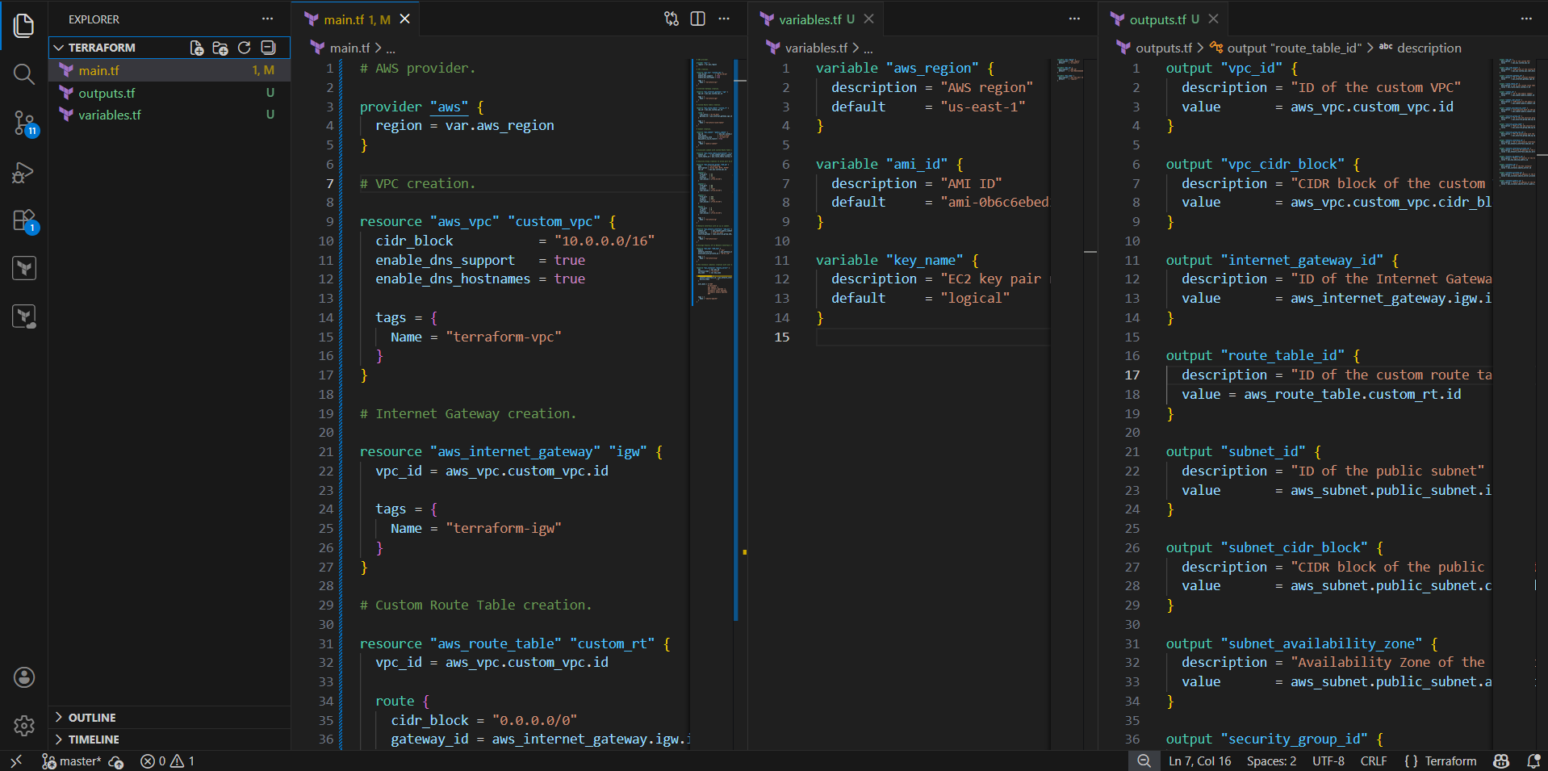

Terraform Commands Execution :

```bash
terraform init
terraform validate
terraform plan
terraform apply
```
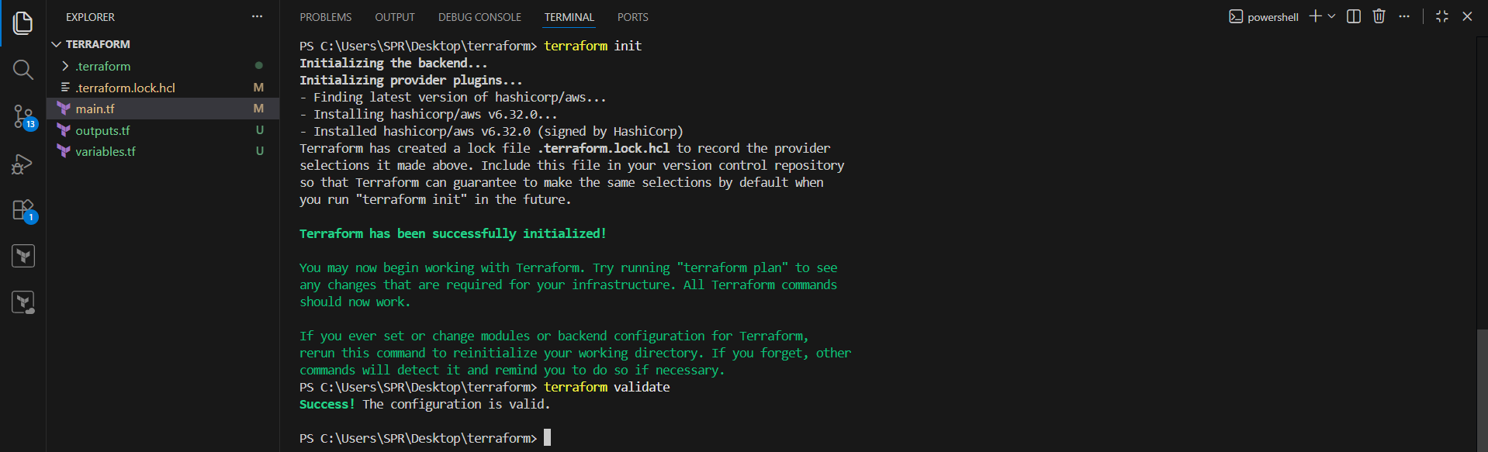

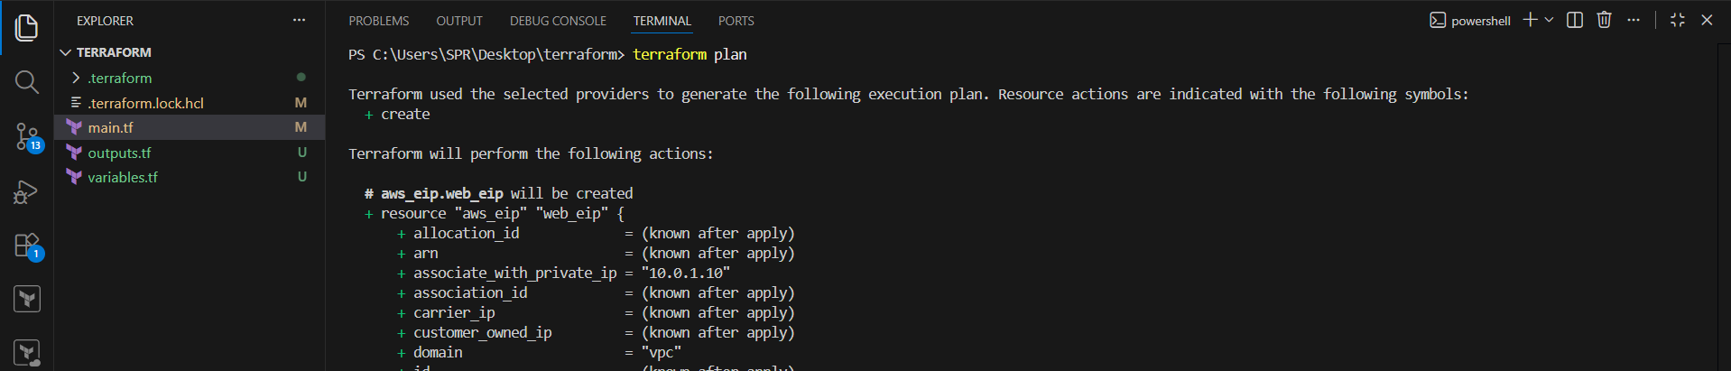
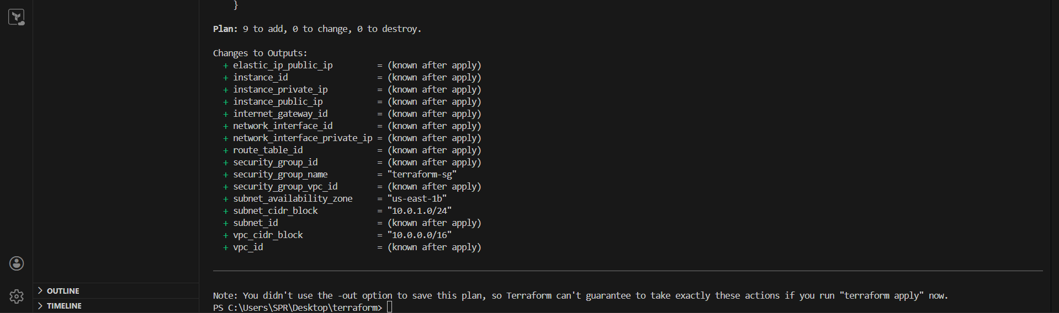

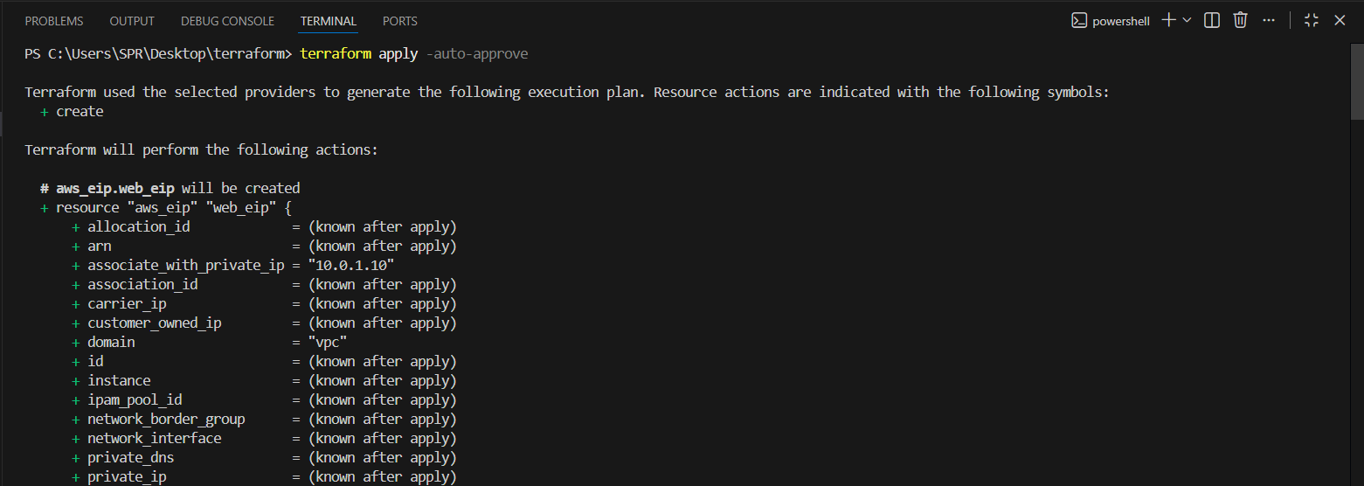
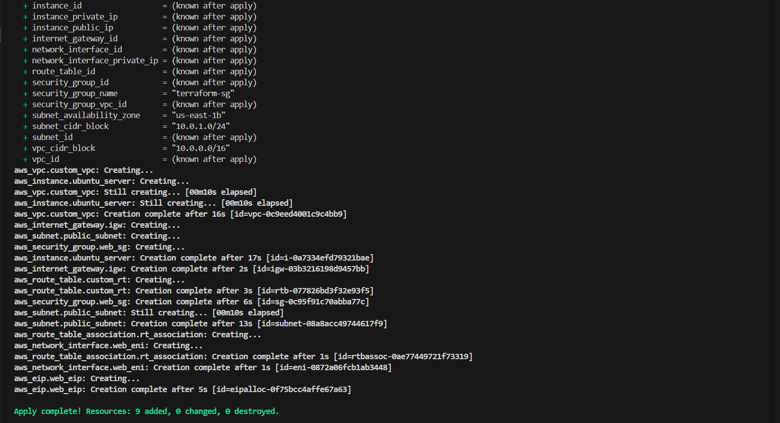
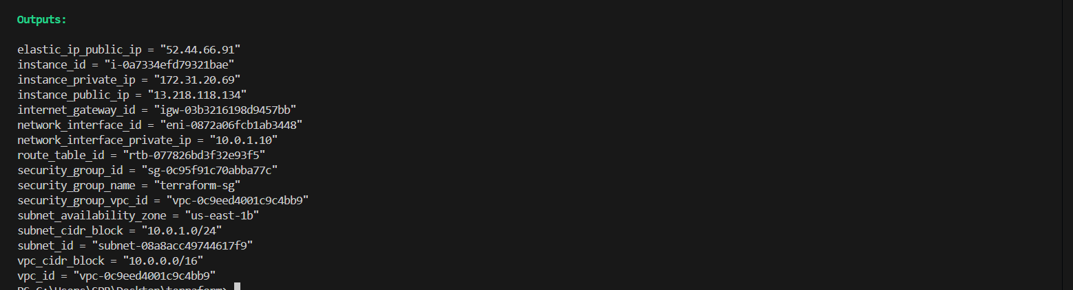

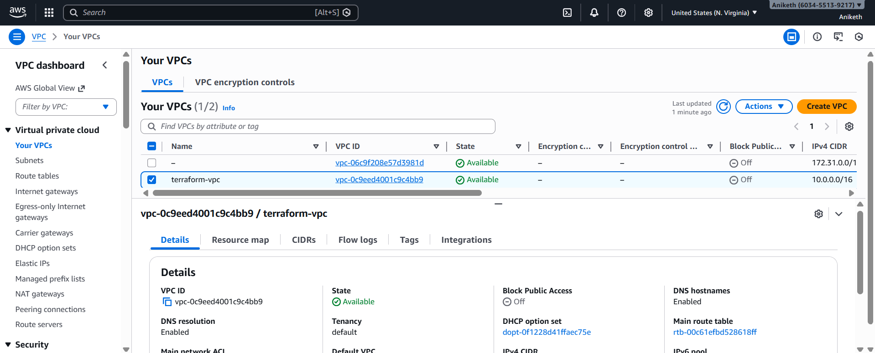
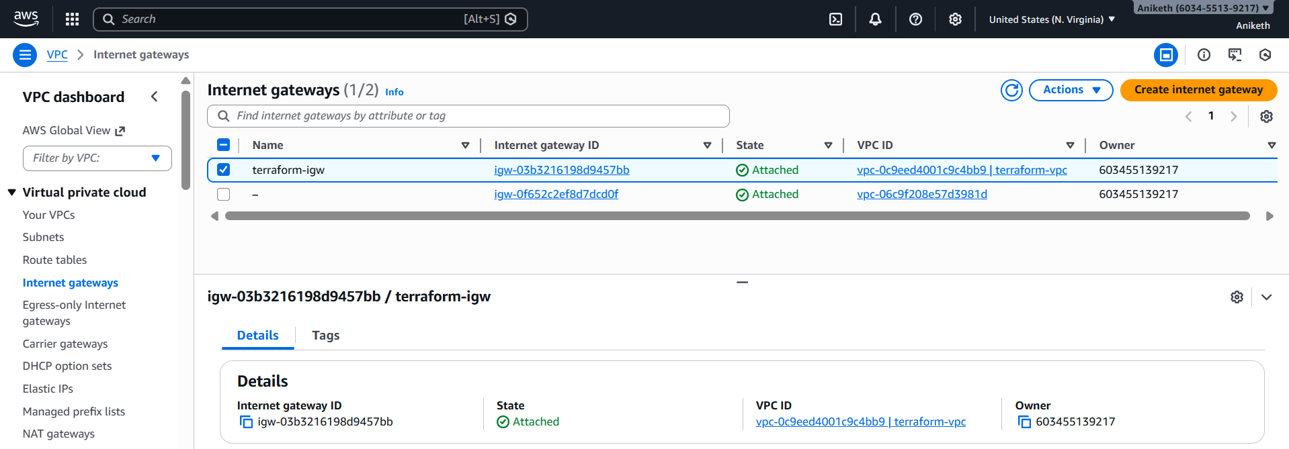

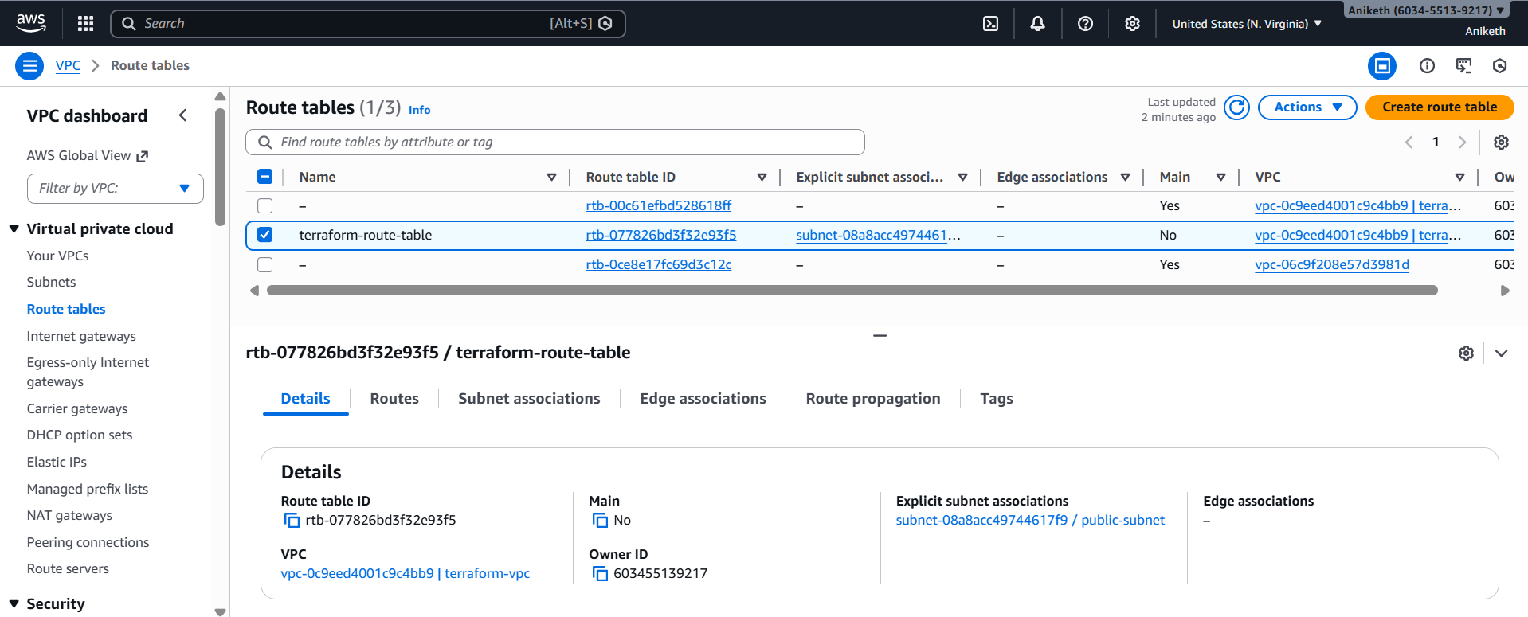
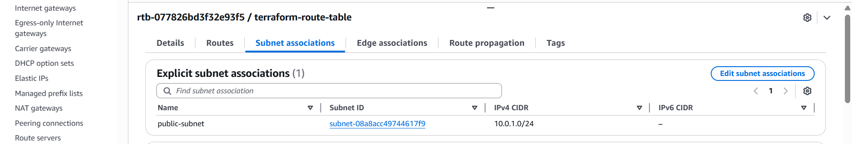

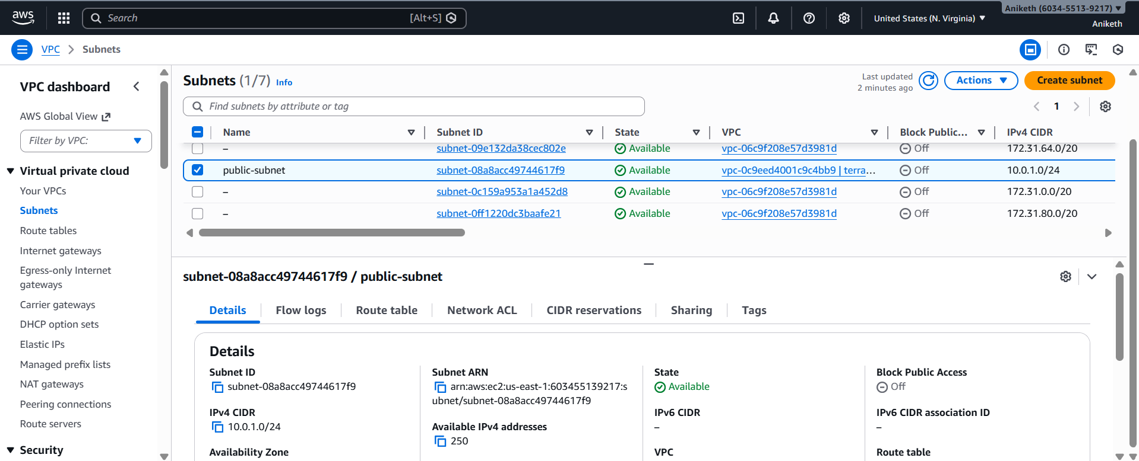

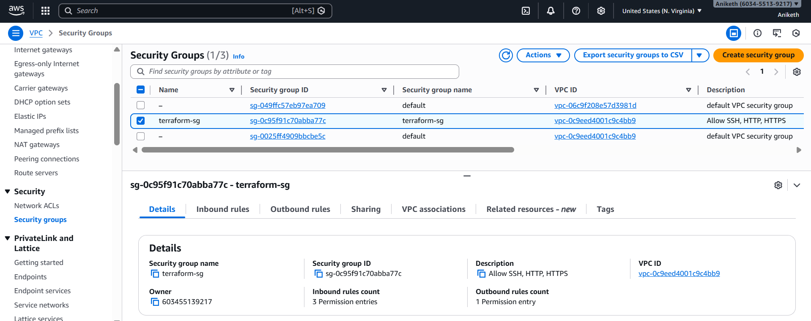
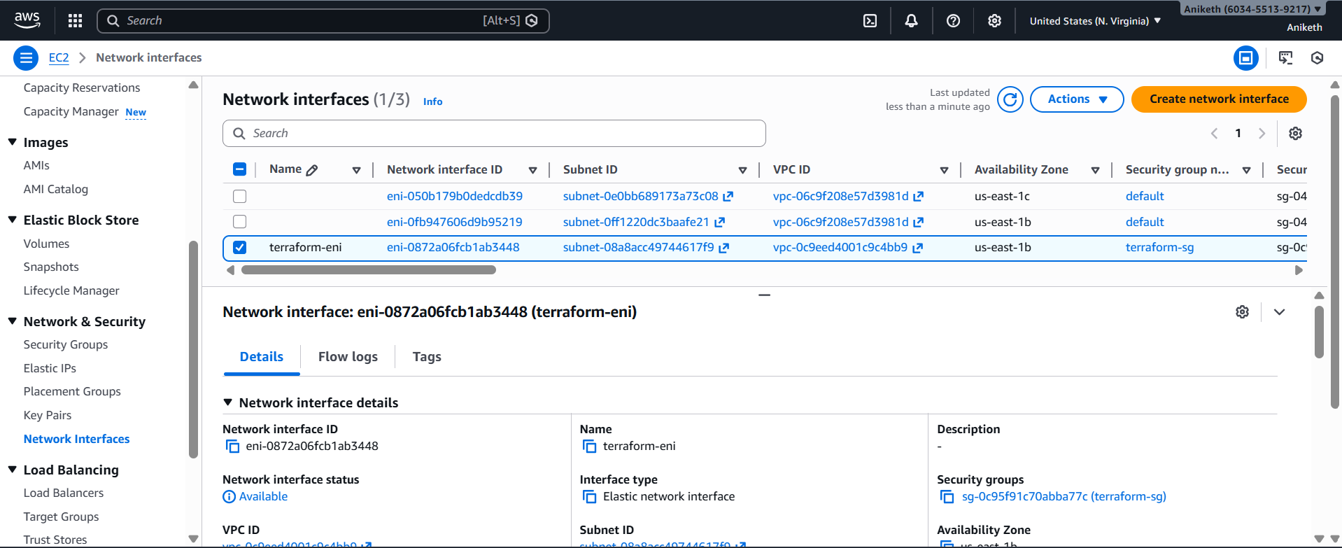

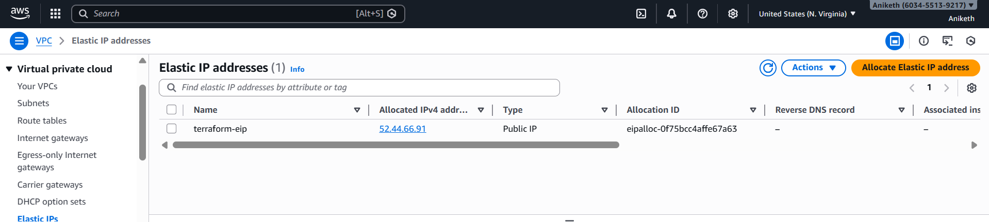

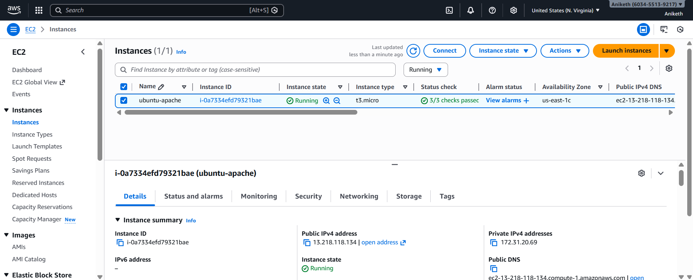

Final Verification :

Open browser:

http://<public-IP>

Apache default page should appear

